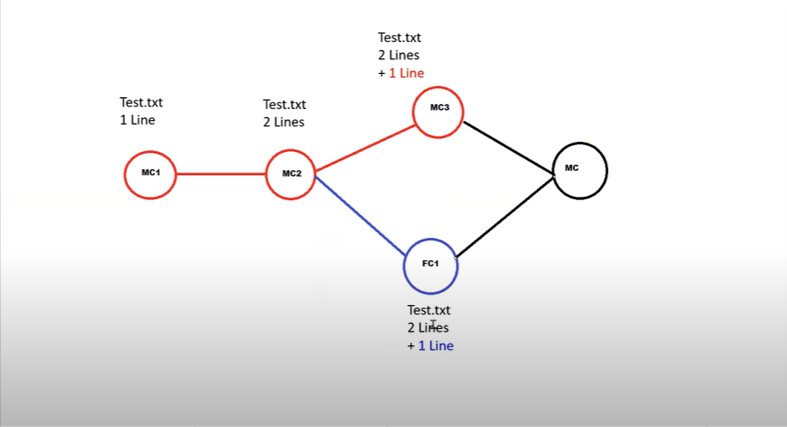**Resolve Merge Conflicts**

Now understand this by practical:-

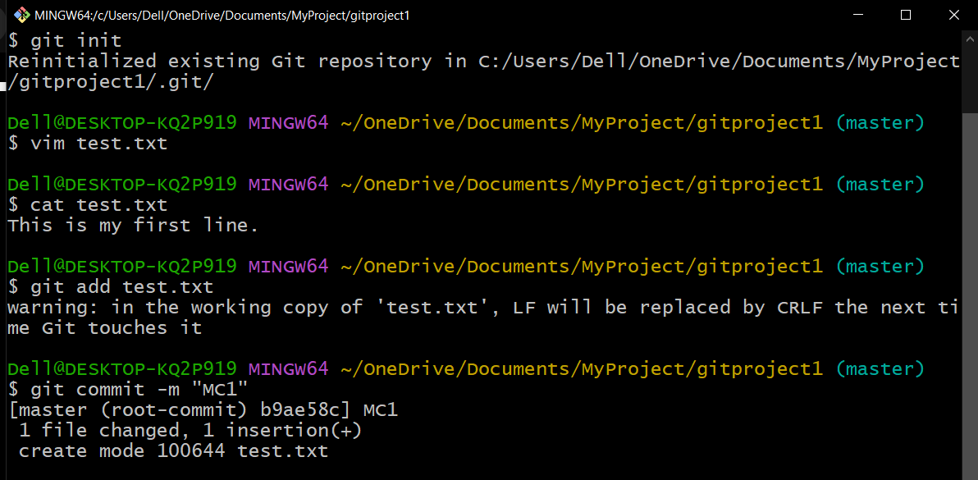Create a file and add the first line. Then commit it as MC1

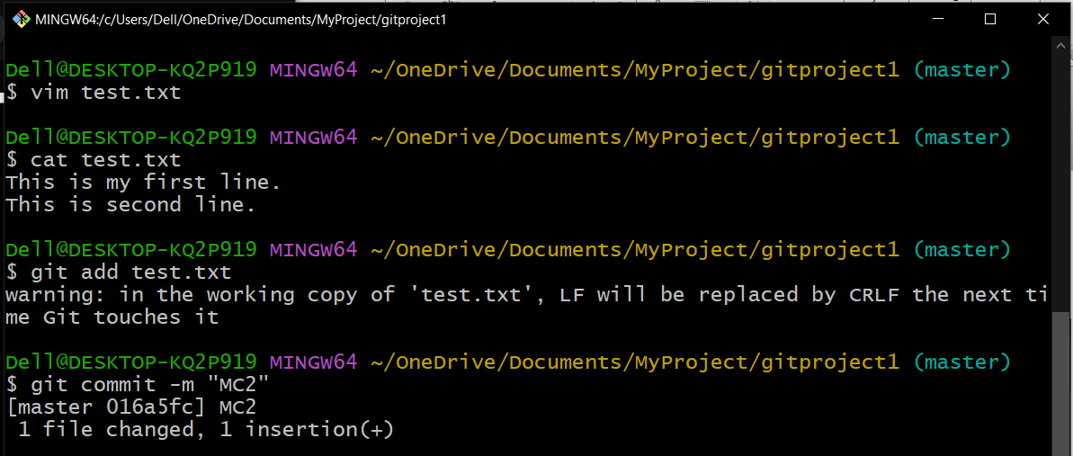Then add second line and commit it as MC2

List all the commits:-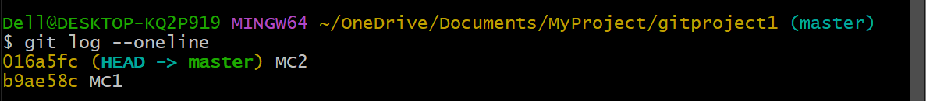

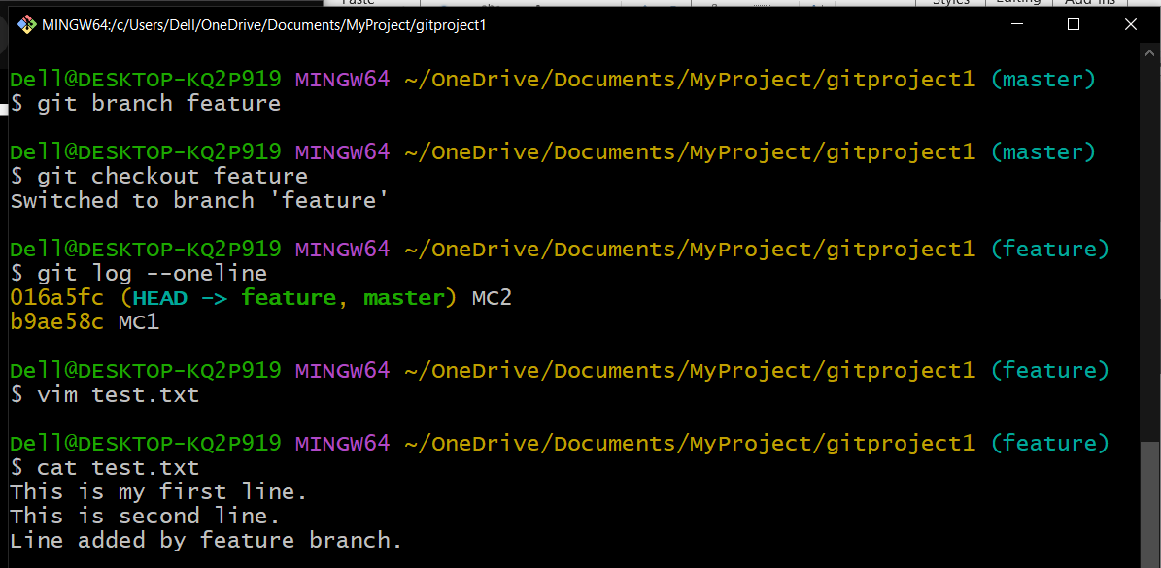Now create a feature branch and add one line in feature branch

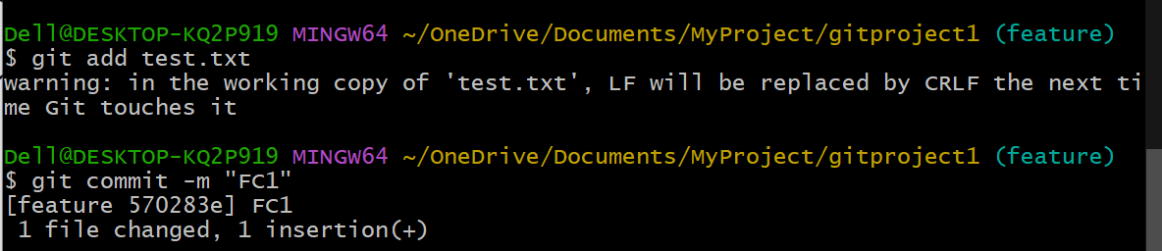

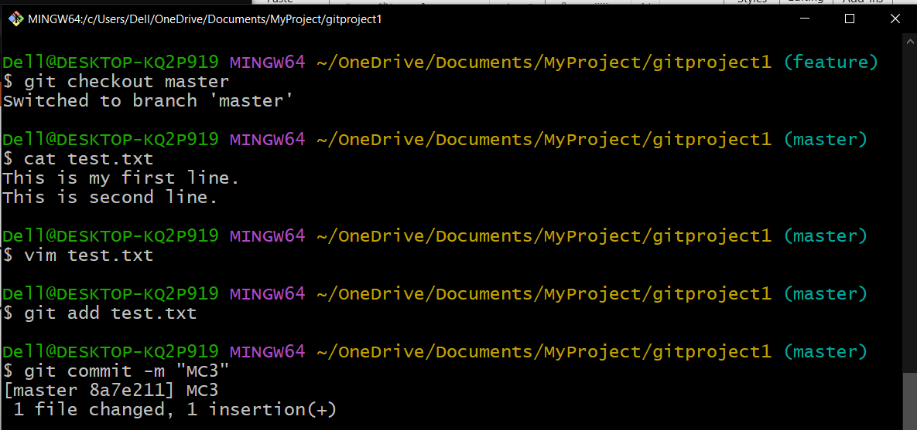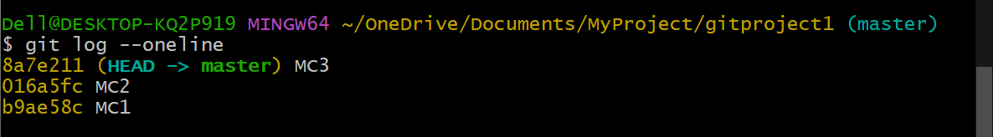Now , switch to the master branch and add one line in master branch and commit it

Now , it’s time to merge the branches and we see the conflicts

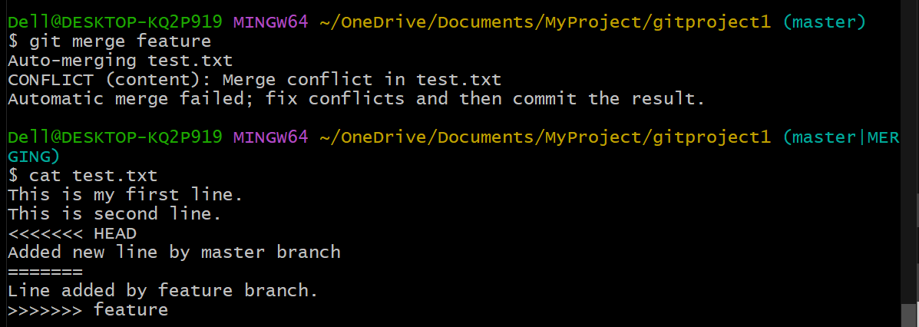

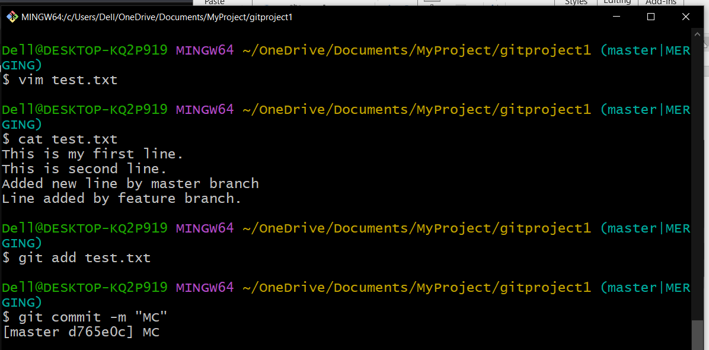To solve the conflict , simply open the vim editor add press “dd” to delete the line you didn’t want and save it.

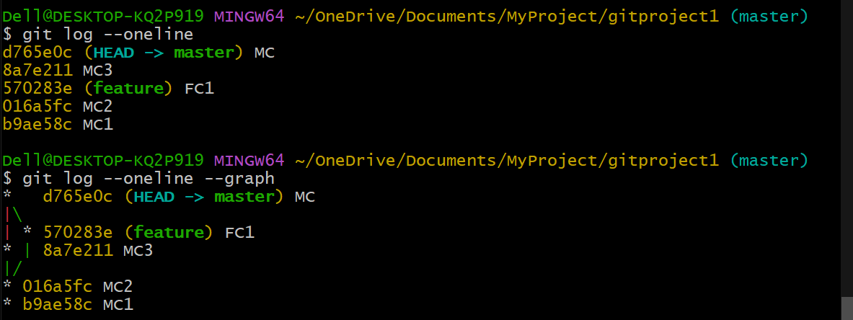

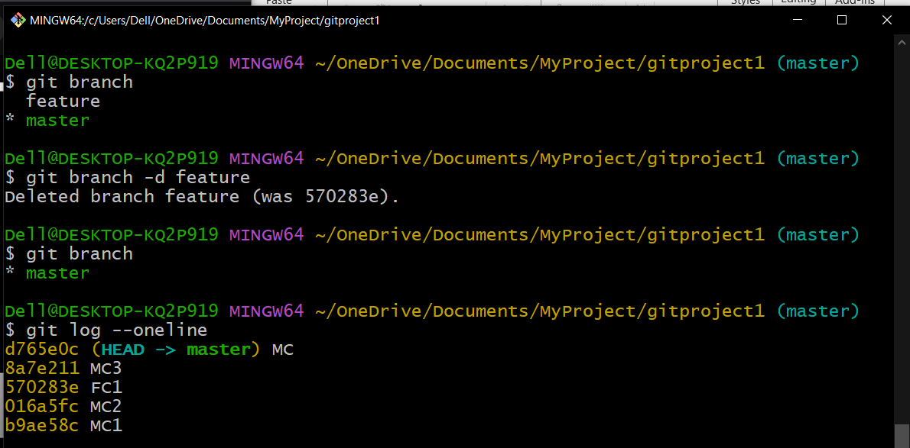After successfully merging the branch , delete the branch